ALTS Auto Mode Simulation Testing

Do the following to run simulation testing in a remote test PC:

1. Start National Instruments Datasocket Server from **‘All Program>> National Instruments>>Datasocket>>Datasocket Server’**
2. Open **‘..\LeakTekDB\ALTS Station1.dsn’** folder with Notepad and notedown the **‘DefaultDir’** & **‘DBQ’** and place **‘..\LeakTekDB\LeakTek.MDB’** file in **‘DBQ’** location.

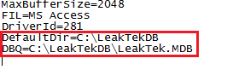

1. Update **‘..\Info\ALTS-2015.ini’** with following details

* Note down the Database location and place the **‘LeakTekDB’** in the that folder
* Update **‘Simulation’** section values to **‘True’**

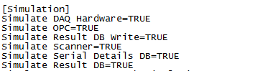

1. Open **‘..\Source Code\ALTS-2015.lvproj’** and update conditional disable symbol **‘Local_PC’** to **‘1’**. **‘DAQ’** engine and setting the Dos with safest values at the exit is skipped.
2. Run **‘ALTS-2015 Startup.vi’** and login.
3. Click **‘Shift+F1’**. **‘ALTS-2015 Auto Mode Troubleshooting Screen’** will be launched in the background.
4. The following steps need to be done in **‘ALTS-2015 Auto Mode Troubleshooting Screen’** to run a test in a station:

* Set **‘Scan Trigger’** to 1.



* Set **‘PC ACK=1’** to **‘0’.**



* Make **‘Robot Available’** to **‘1’.**



* Set **‘PC ACK=1’** to **‘0’.**
* Set **‘Task Pass’** or **‘Task Failure’** to **‘1’** based on the testing carried out.

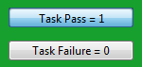

* Make **‘Robot Available’** to **‘0’.**



* Note down the **‘Station’ ‘Test Type’** in the below control and update in the appropriate Station **‘DI’** test type status.

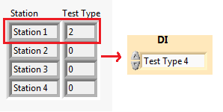

* Set **‘Clamp’** status to **‘Clamped’**. Test Status in main GUI should be **‘Unit Clamped’.**



* Set **‘Start Test’** status **‘1’**. Test Status should be **‘Test Running’**.



* After some time, set either **‘TC_PASS’** or **‘TC_FAIL’** status to **‘High’** based on the type of testing carried on. In simulation mode, even if the test result is a failure, software still does the test pass procedure as the database is not updated with test results in simulation mode.

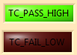

* Set **‘Clamp’** status to **‘Not Clamped’.** Test Status in main GUI should be **‘Unit not Clamped’.**



* Set **‘Stop Test’** status **‘1’.**